EXPERIMENT 9: Word Embedding Visualization using PCA, t-SNE, and UMAP

AIM:
To generate random word embeddings for a sample corpus and visualize them using three dimensionality reduction techniques: Principal Component Analysis (PCA), t- Distributed Stochastic Neighbor Embedding (t-SNE), and UMAP.

PROCEDURE:
- Import numpy, re, PCA from sklearn, TSNE from sklearn, matplotlib.
- Define sample text and preprocess it.
- Build vocabulary and create word2idx mapping.
- Initialize random embeddings with dimension 5 for each word.
- PCA: Apply PCA(n_components=2) on the embeddings.
- t-SNE: Apply TSNE(n_components=2, perplexity=3) on embeddings.
- UMAP (optional): Apply umap.UMAP(n_components=2) if available.
- Define plot(data, title): scatter plot each word with its label.
- Plot PCA and t-SNE results; try UMAP, print install message if unavailable.

CODE:
import numpy as np import re
from sklearn.decomposition import PCA from sklearn.manifold import TSNE import matplotlib.pyplot as plt

text = "language models learn patterns in text language processing helps computers understand language"

def preprocess(text): text = text.lower()
text = re.sub(r'[^a-z\s]', '', text) return text.split()
tokens = preprocess(text) vocab = list(set(tokens))
word2idx = {w:i for i,w in enumerate(vocab)}

embedding_dim = 5
embeddings = np.random.rand(len(vocab), embedding_dim)

# PCA
pca = PCA(n_components=2)
pca_result = pca.fit_transform(embeddings)

# TSNE
tsne = TSNE(n_components=2, perplexity=3) tsne_result = tsne.fit_transform(embeddings)

def plot(data, title): plt.figure()
for i, word in enumerate(vocab): plt.scatter(data[i,0], data[i,1])
plt.text(data[i,0], data[i,1], word) plt.title(title)
plt.show()

plot(pca_result, "PCA") plot(tsne_result, "t-SNE")

try:
import umap
reducer = umap.UMAP(n_components=2) umap_result = reducer.fit_transform(embeddings) plot(umap_result, "UMAP")
except:
print("Install UMAP: pip install umap-learn")

OUTPUT:
[ PCA, t-SNE, and UMAP PLOTS - See Image Placeholder Below ]
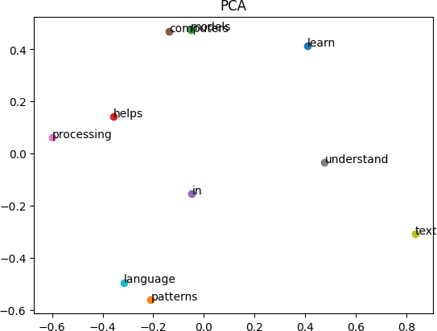

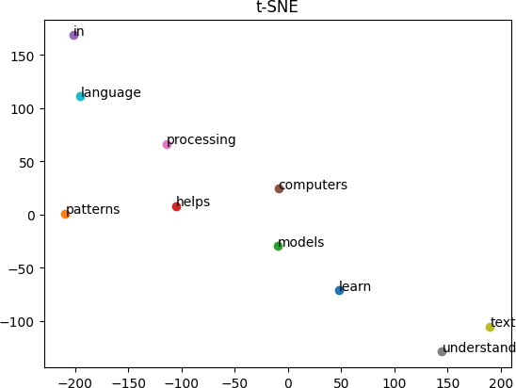
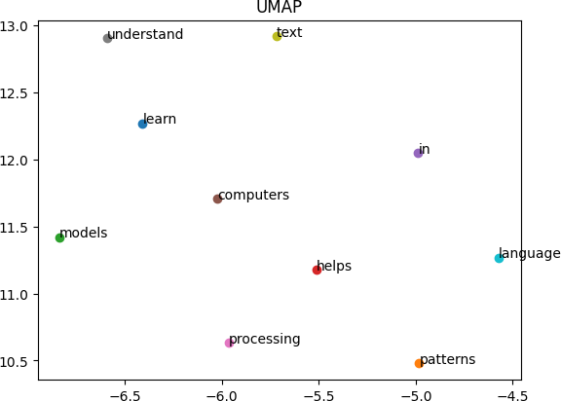

RESULT:
Word2Vec embeddings were successfully generated.Visualization techniques clearly showed word relationships.

